Q2. The variables of the system are:

Input (U): (T_env) Temperature of the environment

State Variable (X): (T_cop) Temperature of Copper block

Output (Y): (T_cop) Temperature of Copper block (Same as state variable)

The state space representation of a linear time-invariant (LTI) system can be modelled by,

X_dot = A * X + B * U

Y = C * X + D * U

This being a single input-single output system, all the matrices A, B, C, D are all scalars. Since our output is the same as the state variable, i.e. Y = X, comparing with the sate space equations we get,

C = 1 and D = 0

Our state space equations boil down to,

X_dot = A * X + B * U

Y = X

The block diagram for this is given by:

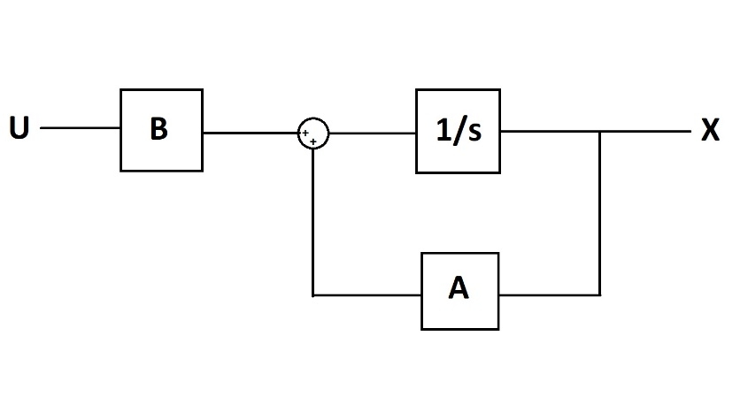

The dimensions of the copper strap are 1m x 10^-2 m^2. Since the cross-sectional are of the strap is relatively smaller, we can make the assumption that the temperature of copper strap across its cross-section is constant. This implies that the heat flow across the cross-section of the strap is 0 and hence a temperature gradient can only exist along the length of the copper strap.

In the problem, the temperature of the block has also been taken to be constant.

Our system will consist of copper in a temperature range ϵ [300K, 400K]. The density of copper at room temperature (300K) is 8960 kg/m^3 and at 400K is 8910 kg/m^3. Since these differ by (8960-8910)/8960 = 50/8960 = 0.558 %, we’ll assume that density is at a constant of (8960+8910)/2 = 8935 kg/m^3.

Specific Heat Capacity = (380 + 390)/2 = 385 J/kg K. [1] [2]

References:

[1] Investigations of temperature dependences of electrical resistivity and specific heat capacity of metal - <https://www.sciencedirect.com/science/article/pii/S0921452616301090>

[2] Heat Capacity of Reference Materials: Cu and W - <https://srd.nist.gov/JPCRD/jpcrd263.pdf>

From the results of the papers, we can observe that heat capacity of copper starts saturating near 300K and doesn’t change much from 300-400K. Hence, we take the specific heat of copper to be a constant of 385 J/Kg K